**WE MID OEL**

**Name: Danish Siddiqui**

**Enrollment: 02-134222-023**

**Output:**

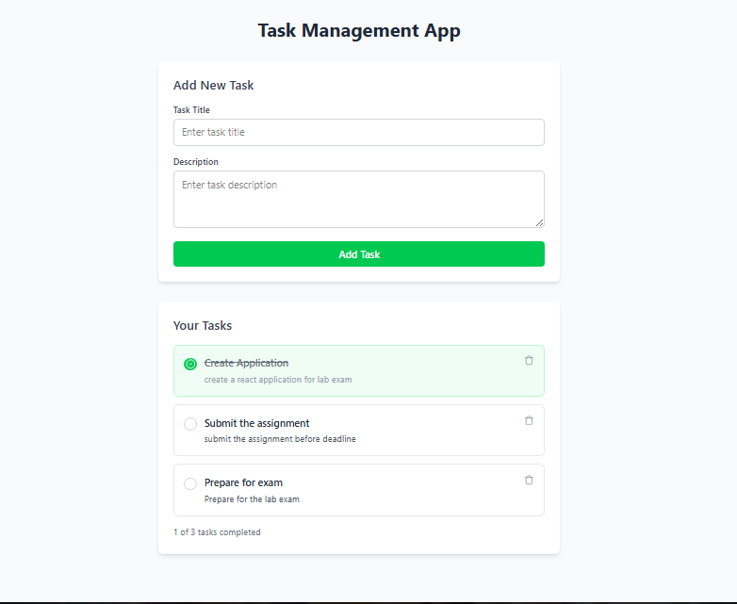

**TaskList component:**

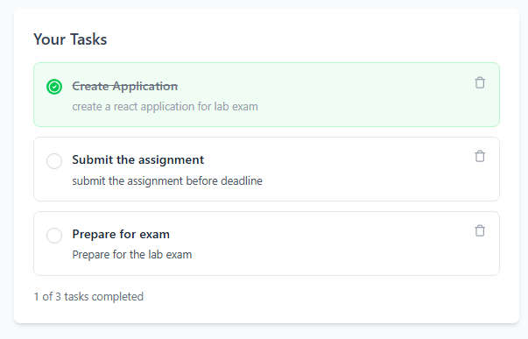

**Task component:**

**When Completed:**

